**Epidemiological update: Ebola virus disease outbreak in North Kivu and Ituri Provinces, Democratic Republic of the Congo**

**Epidemiological update**

13 Jun 2019

[Twitter](https://twitter.com/share?url=https%3A//www.ecdc.europa.eu/en/news-events/epidemiological-update-ebola-virus-disease-outbreak-north-kivu-and-ituri-provinces-4&text=Epidemiological%20update%3A%20Ebola%20virus%20disease%20outbreak%20in%20North%20Kivu%20and%20Ituri%20Provinces%2C%20Democratic%20Republic%20of%20the%20Congo)[Facebook](https://www.facebook.com/sharer/sharer.php?u=https%3A//www.ecdc.europa.eu/en/news-events/epidemiological-update-ebola-virus-disease-outbreak-north-kivu-and-ituri-provinces-4&t=Epidemiological%20update%3A%20Ebola%20virus%20disease%20outbreak%20in%20North%20Kivu%20and%20Ituri%20Provinces%2C%20Democratic%20Republic%20of%20the%20Congo)[Linked In](https://www.linkedin.com/shareArticle?mini=1&url=https%3A//www.ecdc.europa.eu/en/news-events/epidemiological-update-ebola-virus-disease-outbreak-north-kivu-and-ituri-provinces-4&title=Epidemiological%20update%3A%20Ebola%20virus%20disease%20outbreak%20in%20North%20Kivu%20and%20Ituri%20Provinces%2C%20Democratic%20Republic%20of%20the%20Congo)[Mail](mailto:?subject=Epidemiological%20update%3A%20Ebola%20virus%20disease%20outbreak%20in%20North%20Kivu%20and%20Ituri%20Provinces%2C%20Democratic%20Republic%20of%20the%20Congo&body=https%3A//www.ecdc.europa.eu/en/news-events/epidemiological-update-ebola-virus-disease-outbreak-north-kivu-and-ituri-provinces-4)

**As of 12 June, three imported Ebola virus cases and two deaths in Kasese District in Uganda have been confirmed by the Ugandan Ministry of Health. These are the first cases to be reported outside the Democratic Republic of the Congo since the beginning of the outbreak in August 2018.**

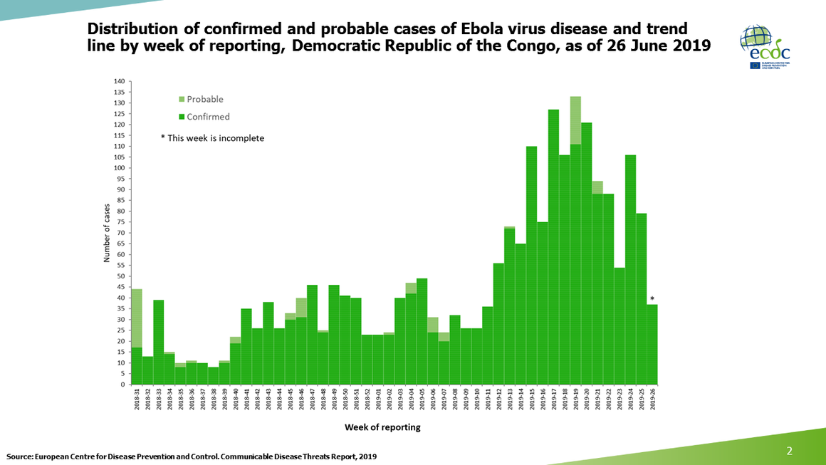 Distribution of confirmed and probable cases of Ebola virus disease and trend line, by week of reporting, Democratic Republic of the Congo as of 11 June 2019 and Uganda as of 12 June 2019

As of 12 June, three imported Ebola virus cases and two deaths in Kasese District in Uganda have been confirmed by the [Ugandan Ministry of Health](https://twitter.com/MinofHealthUG/status/1138769257674788864). These are the first cases to be reported outside the Democratic Republic of the Congo since the beginning of the outbreak in August 2018.

All the new cases are family members with a travel history to the Democratic Republic of the Congo, where they were identified as contacts. Of the six family members, a five-year-old boy (the index case), his grandmother and a younger brother tested positive for Ebola virus disease by PCR. The index case and his 50-year-old grandmother have since died. At the moment, 27 close contacts have been line-listed for follow-up.

In light of the spread of the outbreak outside North Kivu and Ituri Provinces in the Democratic Republic of the Congo, the International Health Regulations Emergency Committee will meet in Geneva on 14 June 2019 to determine if the outbreak is a public health emergency of international concern.

Since the beginning of the outbreak in the Democratic Republic of the Congo in August 2018, there have been 2 084 Ebola virus disease cases (1 990 confirmed, 94 probable) as of 11 June 2019, including 1 405 deaths (1 311 confirmed, 94 probable), according to the Ministry of Health of the Democratic Republic of the Congo.

The number of infected healthcare workers in the Democratic Republic of the Congo is 115, including 38 deaths.

Twenty-two health zones in two provinces in the Democratic Republic of the Congo have reported confirmed or probable Ebola virus disease cases: Alimbongo, Beni, Biena, Butembo, Kalunguta, Katwa, Kayna, Kyondo, Lubero, Mabalako, Manguredjipa, Masereka, Mutwanga, Musienene, Oicha and Vuhovi Health Zones in North Kivu Province and Bunia, Komanda, Nyankunde, Mandima, Rwampara and Tchomia Health Zones in Ituri Province.